- How do I submit a created comment individually?
Two ways to submit a comment
- After creating the comment Click the create button and from the comments thread select the Submit link
- After creating the comment Click the Create and Submit button submits the comment

- How do I submit all of the created comments at a time?
After entering the comment, then Click the Create button repeat the same process for all the comments when all the comments are entered Click the Submit All Comments link displayed at the bottom of the page.
- How do I submit all the responses at a time?
After entering the response click the Respond button repeat the same process for all when all the responses are entered Click the Submit All Responses link
- How do I submit responses individually?
There are two ways to submit responses.
- After creating response click the Respond button and from the comments thread, click the Submit link
- After creating the response Click the Respond and Submit button submits the response.

- How do I know to whom the comment is assigned to: after the comment is created and submitted?
After submitting the comment, in the comment threads the name of the person with the role to whom the Comment is assigned is displayed beside the Assigned To: label.
- How do I know if the comment is assigned to me?
If you see anything listed under Action Items in the Home Page, then that comment is waiting for your action. In other words, you are the next responder.

- Total, Due Today, Due This Week will also let you know how many comments are assigned to you, how many are due today and how many are due this week.

- How do I go to the Submittal from the email notification I received?
From the email notification, click on the Link to the Submittal link, login using your login id and password it will redirect to the Submittal Information page of that Submittal.
- How do I know that I’ve been removed from a Submittal?
- You will receive an email notification if you are removed from a submittal
- Search for the submittal through Search page and click on the required submittal link. When the submittal opens click on the Staff Assignments tab look for your name in the staff Assignments if it does not display your name then you have been either removed or not added to that submittal

- What should I opt for, if I don’t want to create a comment?
In the comments page select the Mark as No Comment check box.
- How does my manager know that I’ve opted for “Mark As No Comments”?
In the Staff Assignment page in the row where your name is displayed, it will display 0* under Comments Created section and your manager will know it as you have opted for No Comments. Also the description will be displayed under the Reviewer section as
*Marked as No Comment.
- Can I select ‘Mark as No Comment’ after the comment is created?
No. ERC will not let you ‘Mark as No comment’ if you have already created a comment.
- I am assigned on a submittal and I have to create a new comment to the submittal. Why am I not seeing ‘Create a new comment’ link?
If your Comment Due Date is expired then you are not allowed to create a new comment and you don’t find the link to create a comment. You can request a due date extension from the in-house project manager, which gives you the ability to create a new comment.
- If the Submittal Comment Due Date is extended, will the Assignment Comment Due Date extends?
Yes. If the Comment Due Date of the submittal is extended, then the Assignment Comment Due Date extends automatically.

- Can a Designer respond to the comment after the assignment Response Due Date is expired?
Yes. If the comment is still open then Designer can respond to the comment even after the assignment Response Due Date is expired. Due Date on a Submittal is just a warning that your response date is due.
- I am assigned to the submittal and I have to comment/respond to the
Submittal and I don’t find the submittal in the home page or I don’t receive any responses/ comments?
If your submittal status is Closed or On-Hold, then the submittal will not display in the home page under Assigned Submittals section and you don’t receive any comments/responses.
- How do I know that the submittal is closed or On-Hold?
If you are assigned to a submittal and if you don’t find that submittal under Assigned Submittals section then your submittal status is either closed or on-hold. Only an In-house Project Manager or a District Admin can bring it back to Open Status.
- How to view/print the Submittal information
Every Submittal has a Reports tab from your Submittal select the Reports tab from the displayed links select Show Submittal link to view/print the Submittal information and Assignments/Roles for that submittal.
- How to view/print all the comments in a Submittal
From the Reports tab select Show All Comments link to view/print all the submittal comments.
- How can I view/print my individual Comment Reports?
From the Reports page select Show My Comments link to view/print all of your comments, responses submitted to you.
- How to export the comments to PDF or Excel?
Select a Submittal and click on the Reports tab in the Reports page from the displayed links, click on a required link In the Submittal Report page click the Select a Format drop down and select a required option Excel or Acrobat (PDF) file. After selecting the required option the Export link is enabled, click on the Export link. Follow the prompts to Open or Save the results. The search results list will open in selected format.

- Can I view/print Comments by Category?
Yes, from the Reports page select Show Comments by Category link from the displayed list select the required category and select the Show Report button displays all the comments entered for the selected category
- How do I look for the comments assigned to other staff and all the comments/responses entered by other staff in a Submittal?
In the Comments page by default the Show comments Assigned to me check box is checked, uncheck the Show comments Assigned to me check box. It will list all the comments Assigned to other staff and entered by other staff for the selected submittal.
- When assigning comments to the Designer to enter the responses for their discipline, do I have to assign one comment at a time?
If the designer assignment category is already defined in the Staff Assignments tab, then all the comments will be directly assigned to them as long as there is no other designer with the same defined category.
- If there are multiple designers with the same category, how does the Project Manager assign comments to the designers to respond?
If multiple designers have the same category then the Project Manager will have to assign the comments individually to the designers.
- How can I delegate a staff to work on my behalf?
From Settings select Manage Delegates enter the first or last name of the required staff in the Choose Your staff member Delegate text box: and select the name from the displayed list and select Add button adds the staff as your delegate.
- Which staff has the ability to add a delegate/work as a delegate?
Only the employees with a RACF/Mainframe Id can add a delegate/work as a delegate.
ISA users do not have delegate option.
- How do I know when I am someone’s delegate?
When someone selects you as their delegate, you will receive an e-mail. If you are removed as their delegate you will again receive an e-mail.

- How do I work as a delegate?

Using “Work As” To find out who has selected you as a delegate is to see what names are available in your “Work As” list located in the upper right of the page.
- When you need to work in ERC on behalf of your delegator, click on the Work As drop down.
- Select the person you need to work as. Making this selection will mean you now have the access to work with that person’s access within ERC. Any work you do on their behalf will be documented as being done by you, but on their behalf. You may make this selection on any screen. The system will immediately present you with their level of access.
- When you are done working as a delegate don’t forget to change back to Self from Work As

- How to take a screenshot of the window/image in ERC?
Pressing the keys Alt + Print Screen will take a screenshot of the currently selected window. This allows you to target that specific window that you have open.
Go through these 3 simple steps to capture a screenshot and send it via email...
- Take your full screenshot of your currently open window or selected window by pressing the Alt key + Print Screen key.
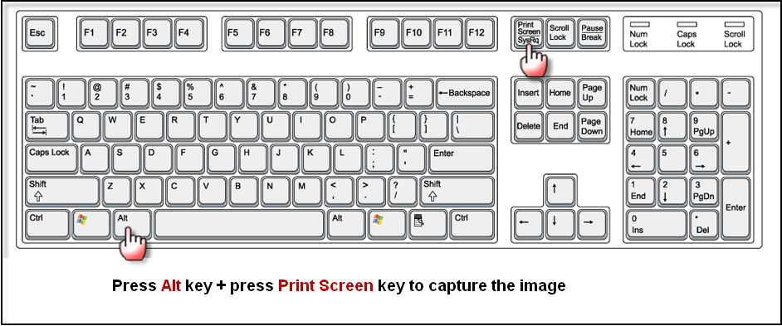
- Open a new email message and position your cursorin the body of the email where you would like your captured image to be placed.
- Press Ctrl + V 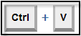 on the keyboard to paste the captured image into your new email (or) right click your mouse and select Paste.
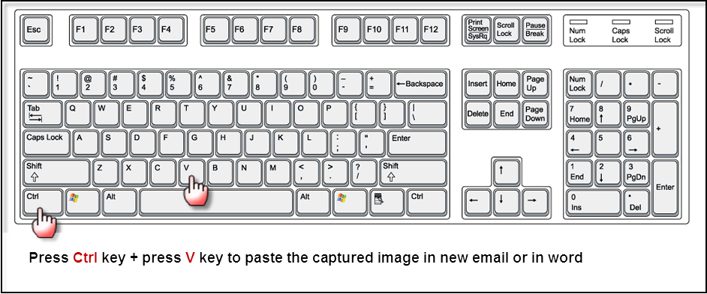
In Short: Print Screen (Press Alt + Print Screen) > open New Email > Press Ctrl + V > Send Email.

